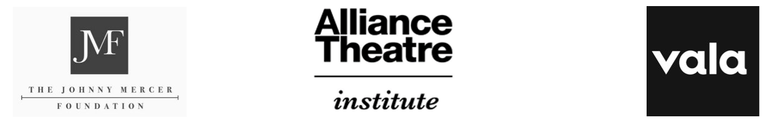

The Songwriting Process
Instructional Resource: Lessons 1-4 – Concept, Lyrics, Music, and Production

Video # | Notes  (Record Strategies and Tips Presented in the Video, Below) | Original Composition  (Generate Ideas for Your Own Song, Below)
#1 – Concept |  | What will your original composition (song) be about)?  Summarize (boil down) the concept into just one word.
#2 – Lyrics |  | Word Dump:
#3 – Music |  | Which sounds (instrumental or other) would best support the story?
#4 – Production |  | (+) Song needs more: | (-) Song needs less:

